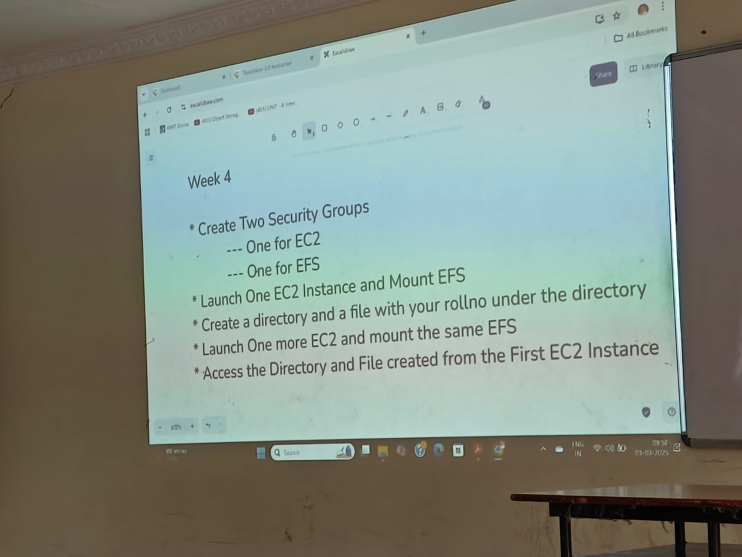**Week-4 EFS**

Stepi) Create two security groups

For Ec2

1) Go the Security group dashboard and click on Create security group

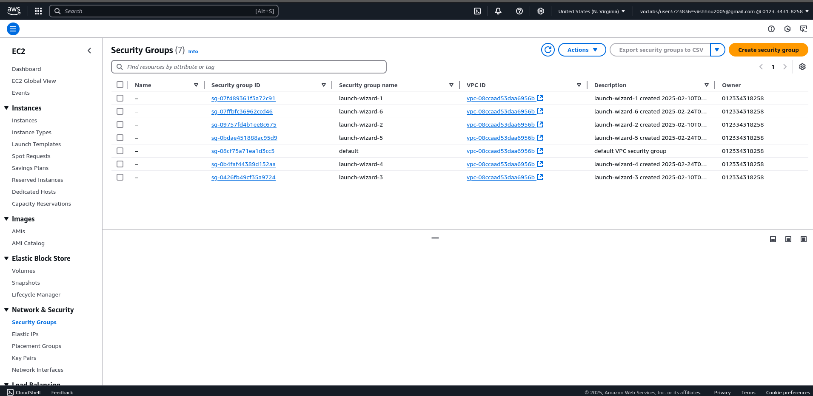

2) Select SSH and anywhere

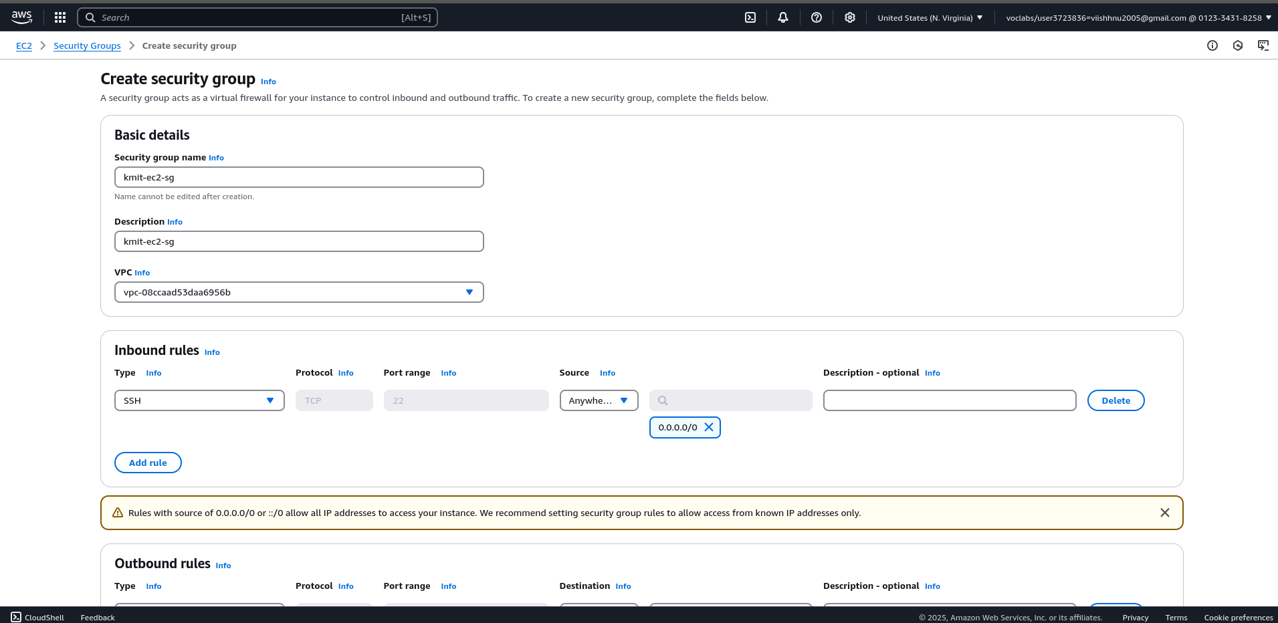

3) Now the security group is created

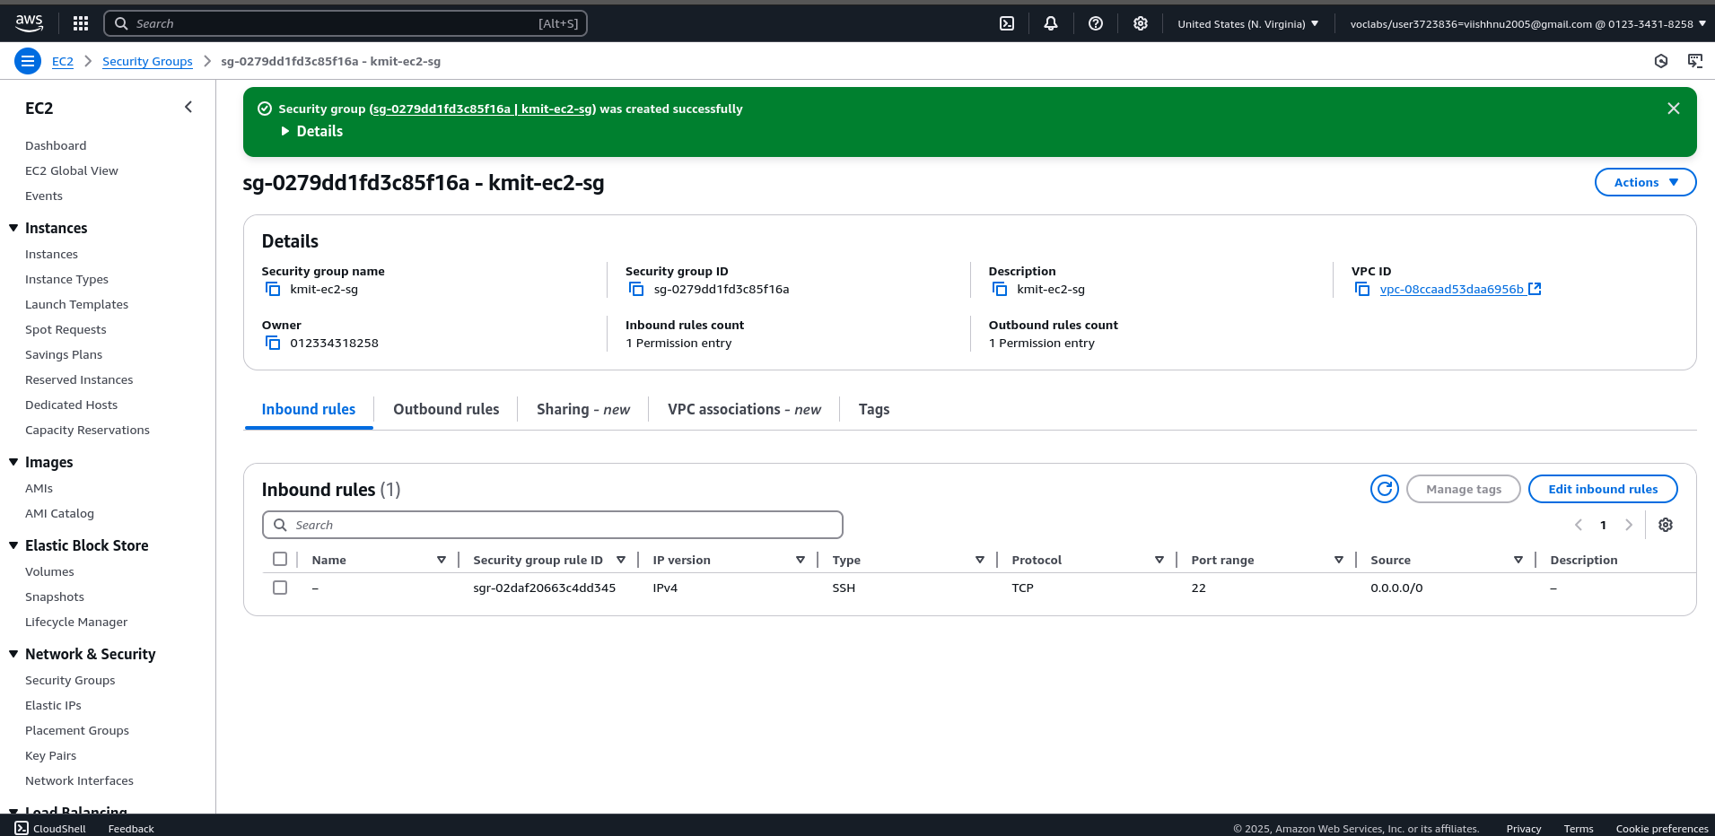

Stepii) Create another security group for EFS

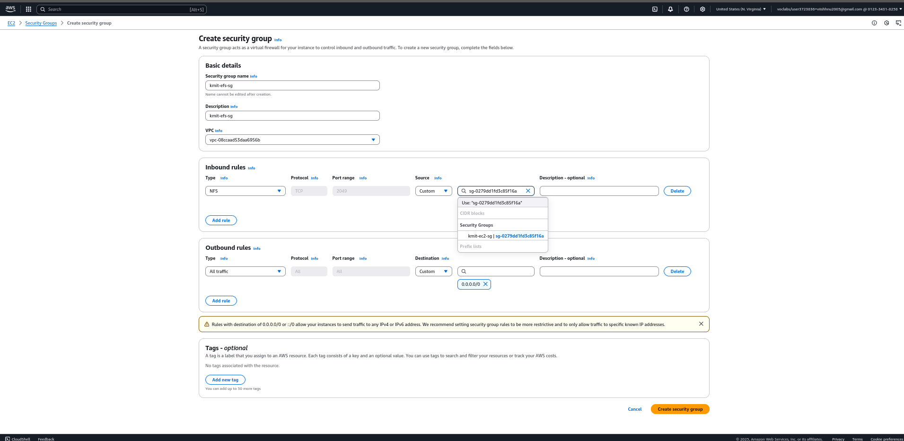

Stepiii) Now create two EC2 instances in two different availability zones us-east-1a and us-east-1f

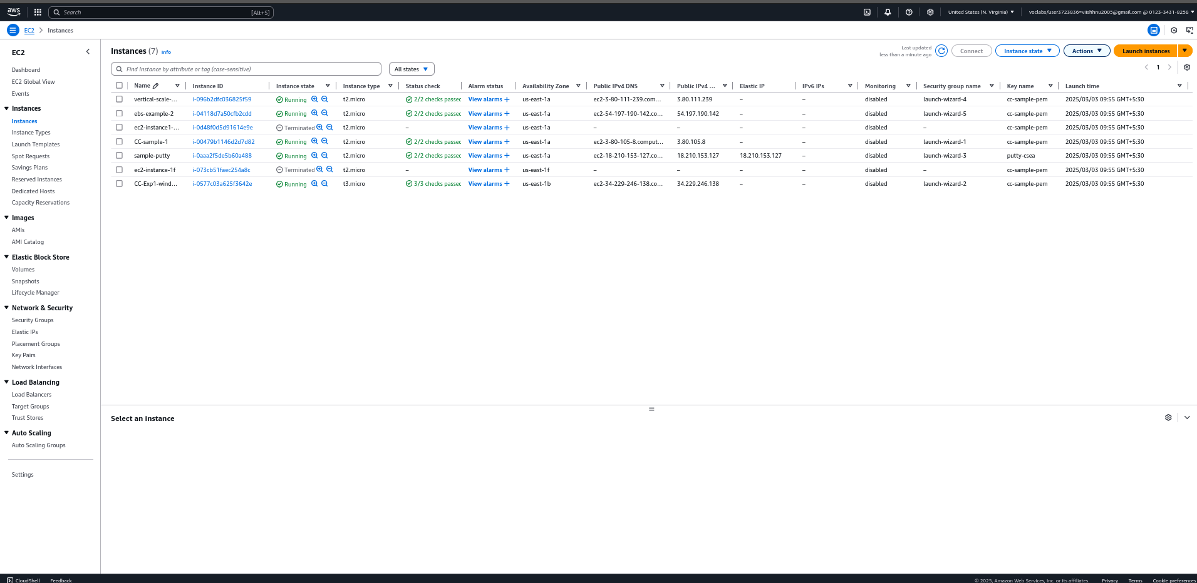

1) Create first ec2 instance

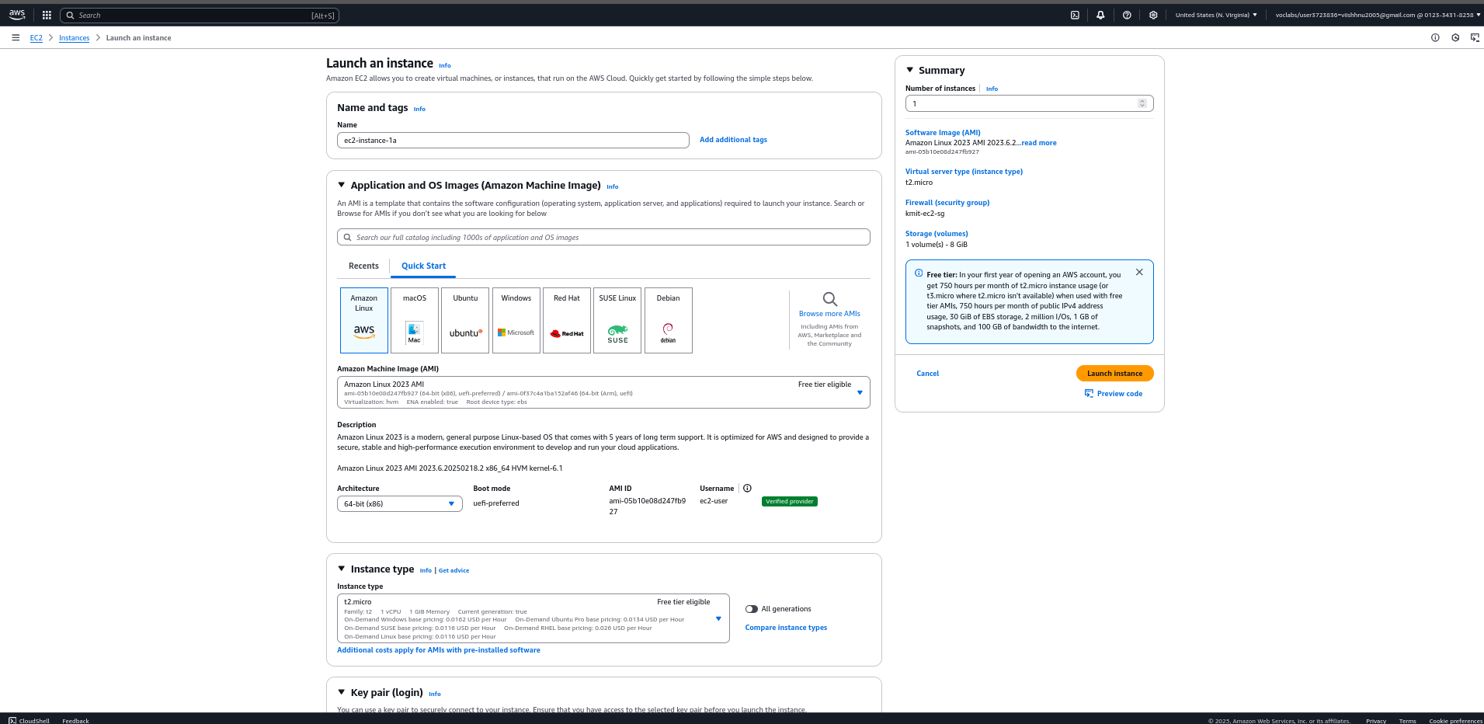

Click on Launch instance

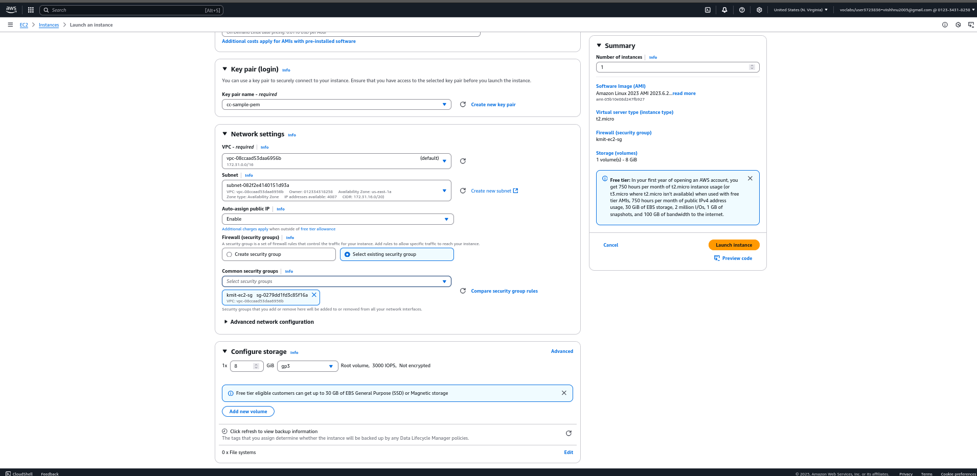

2) Now launch another Ec2 instance

ec2-instance-1f

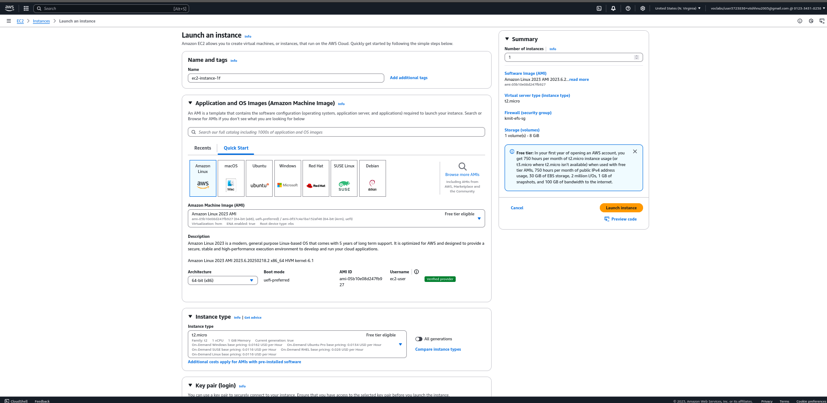

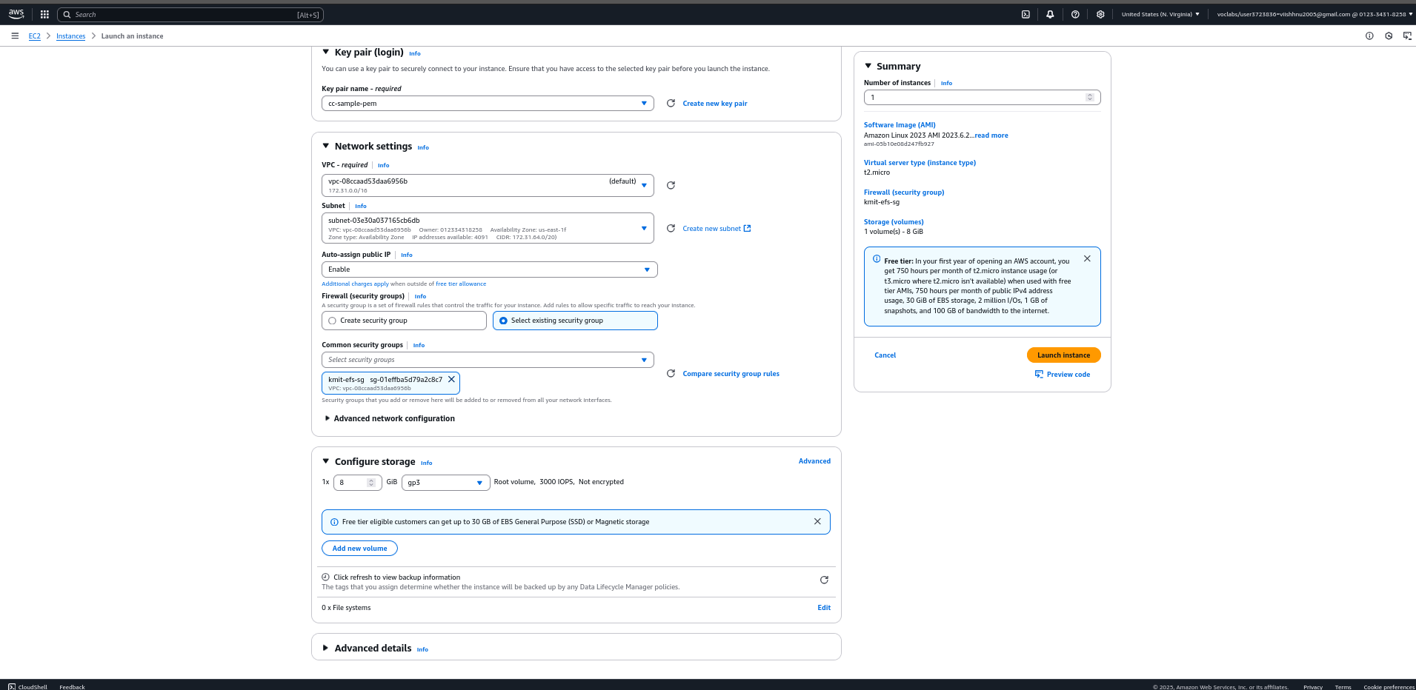

Stepiii) Now Create a EFS

1) Now click on create file system

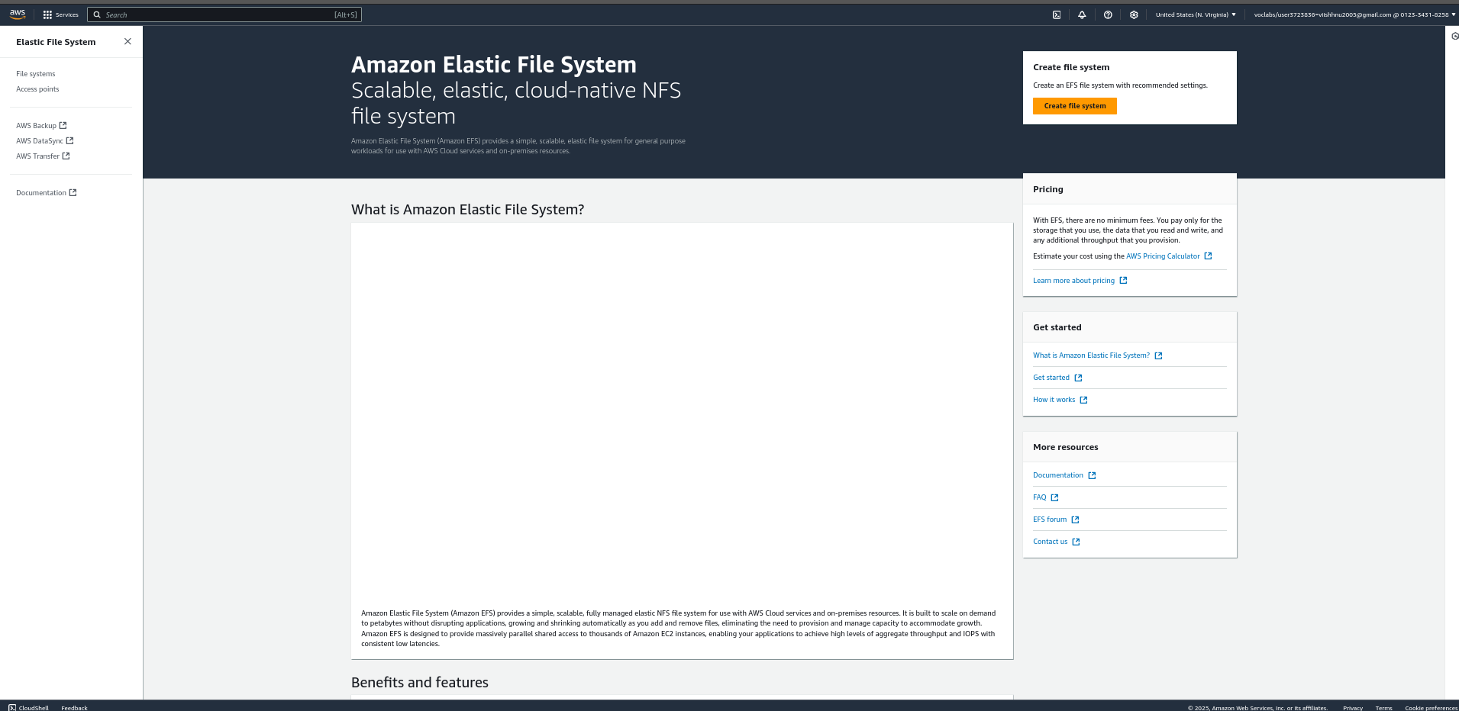

Now click on customize

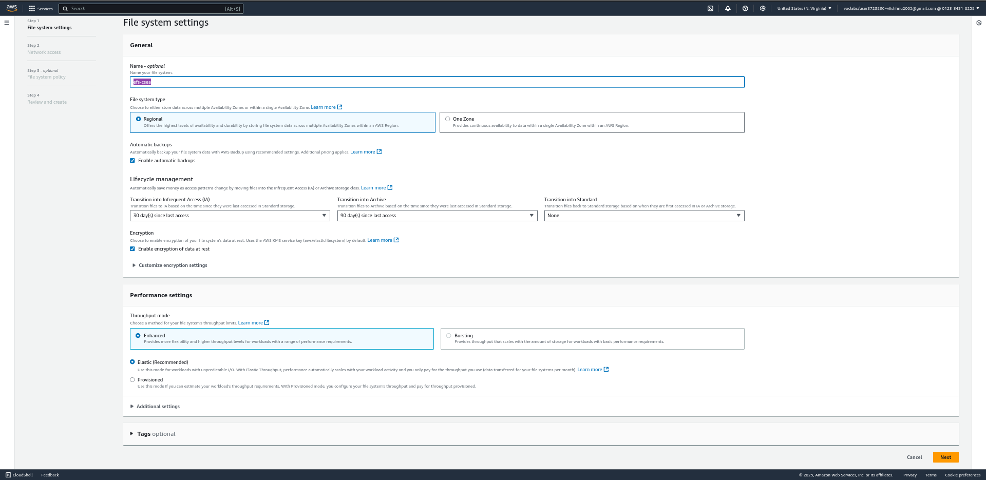

Click on next and move to network access

2) Now remove uneccessary availability zones(except 1a,1f)

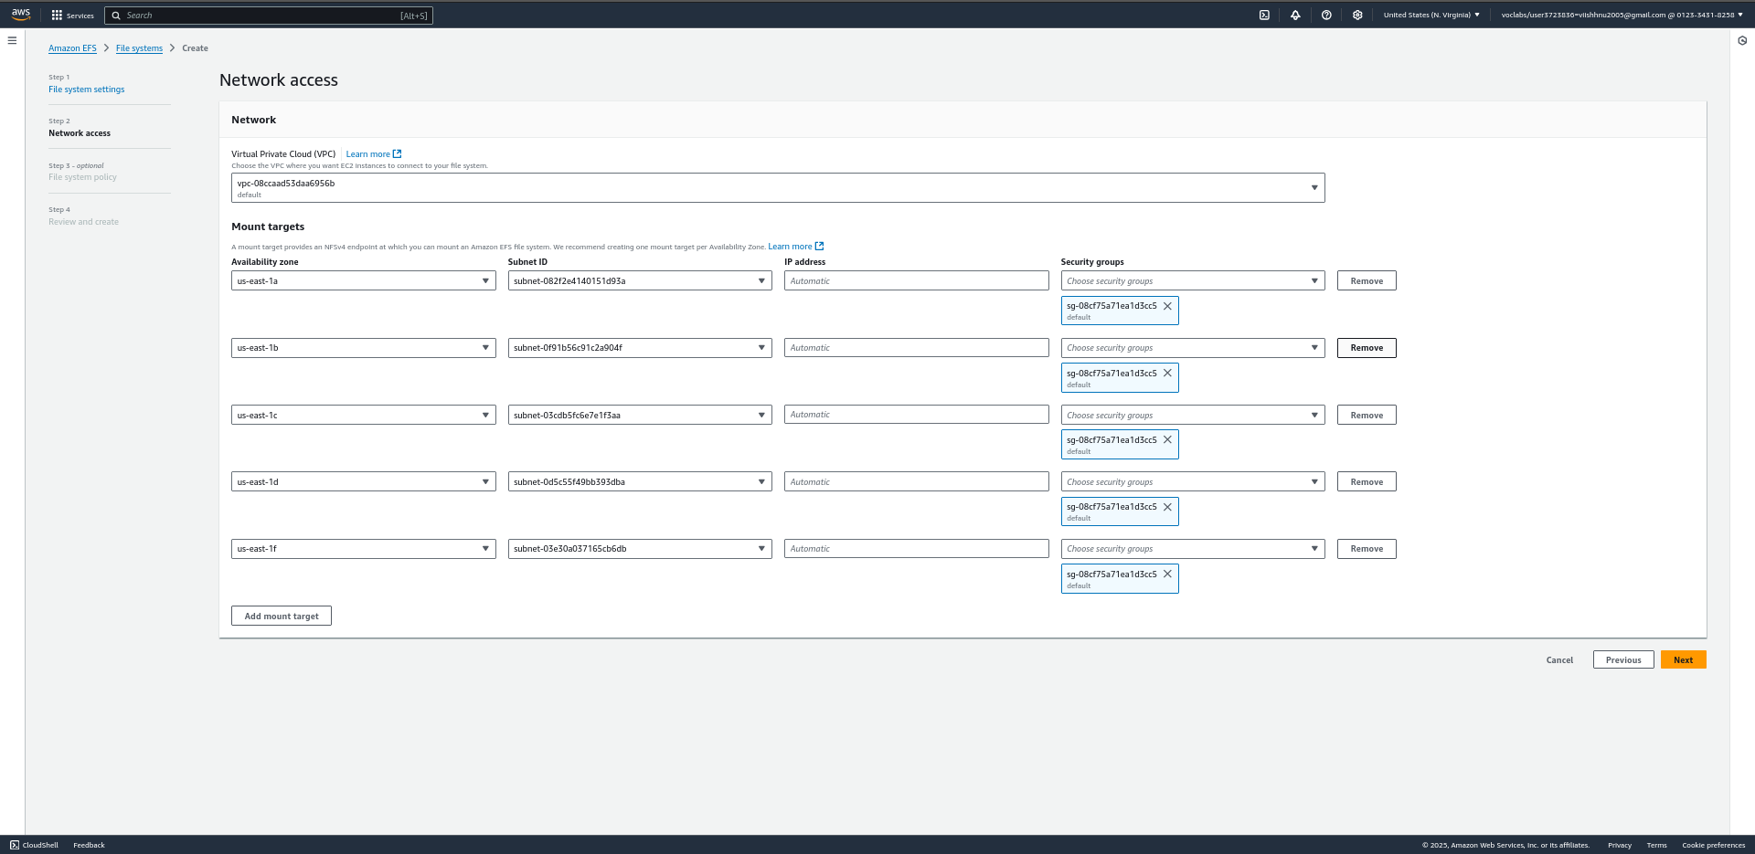

Now select efs-security group for mount targets

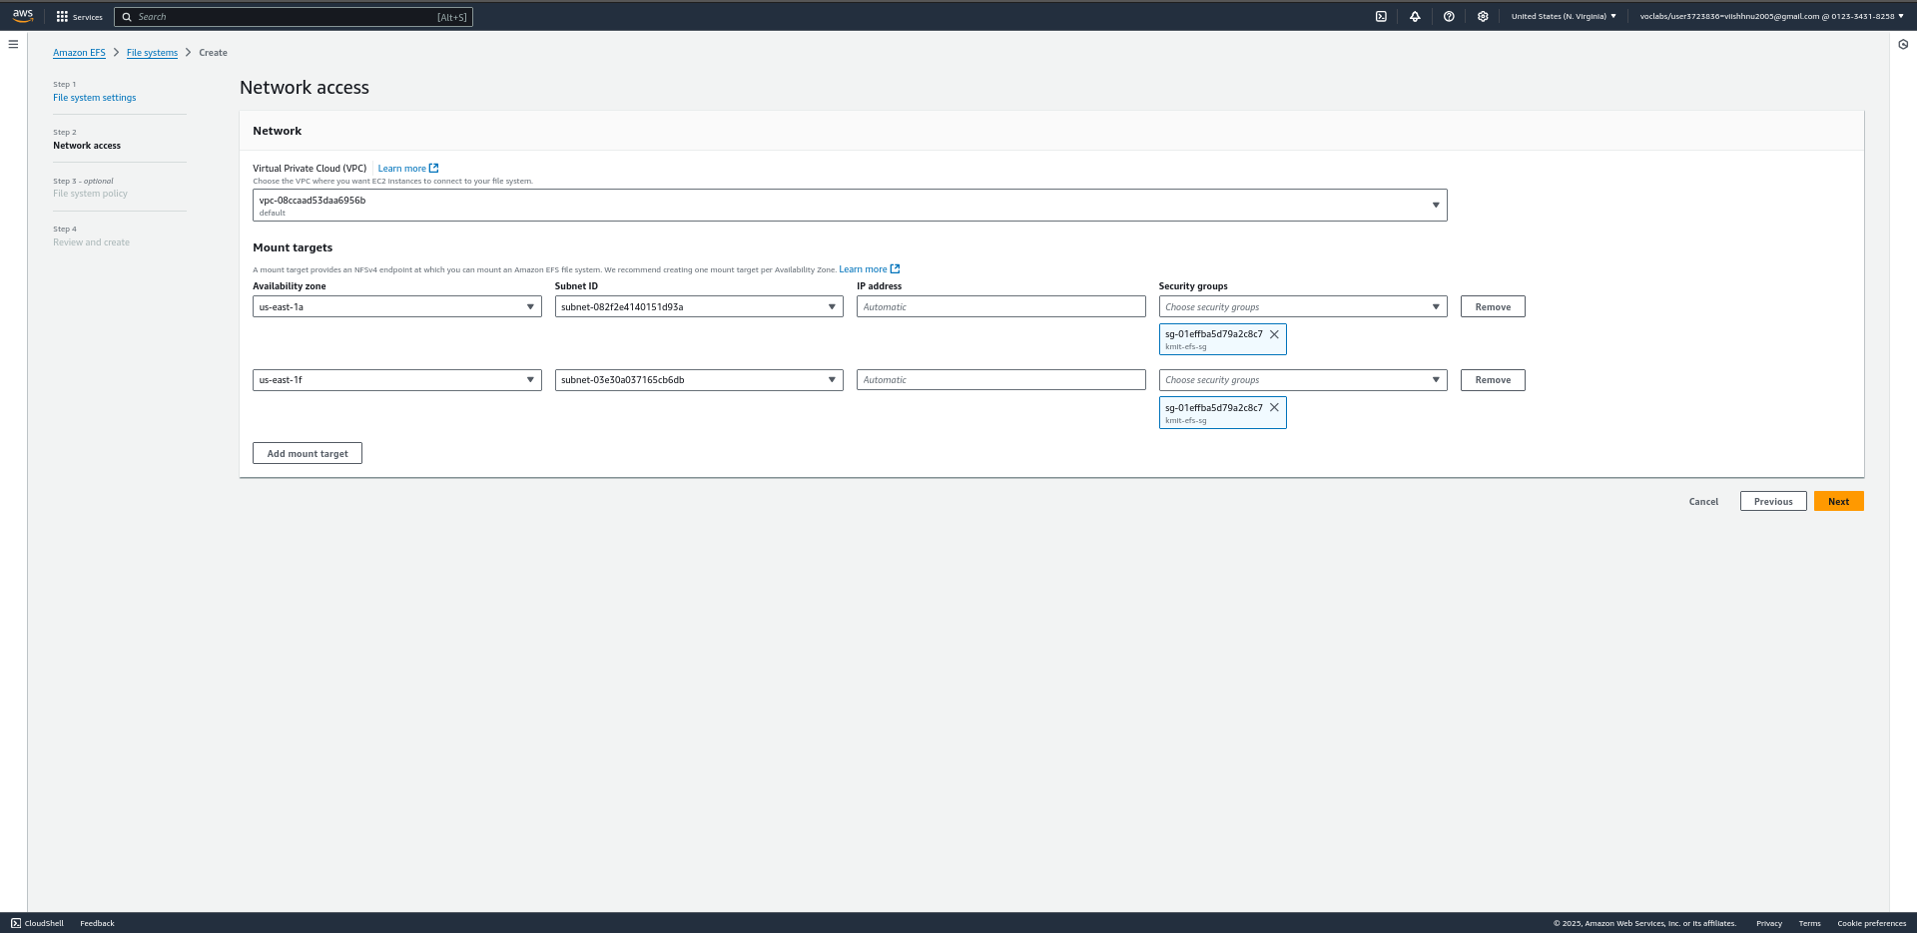

Click on create

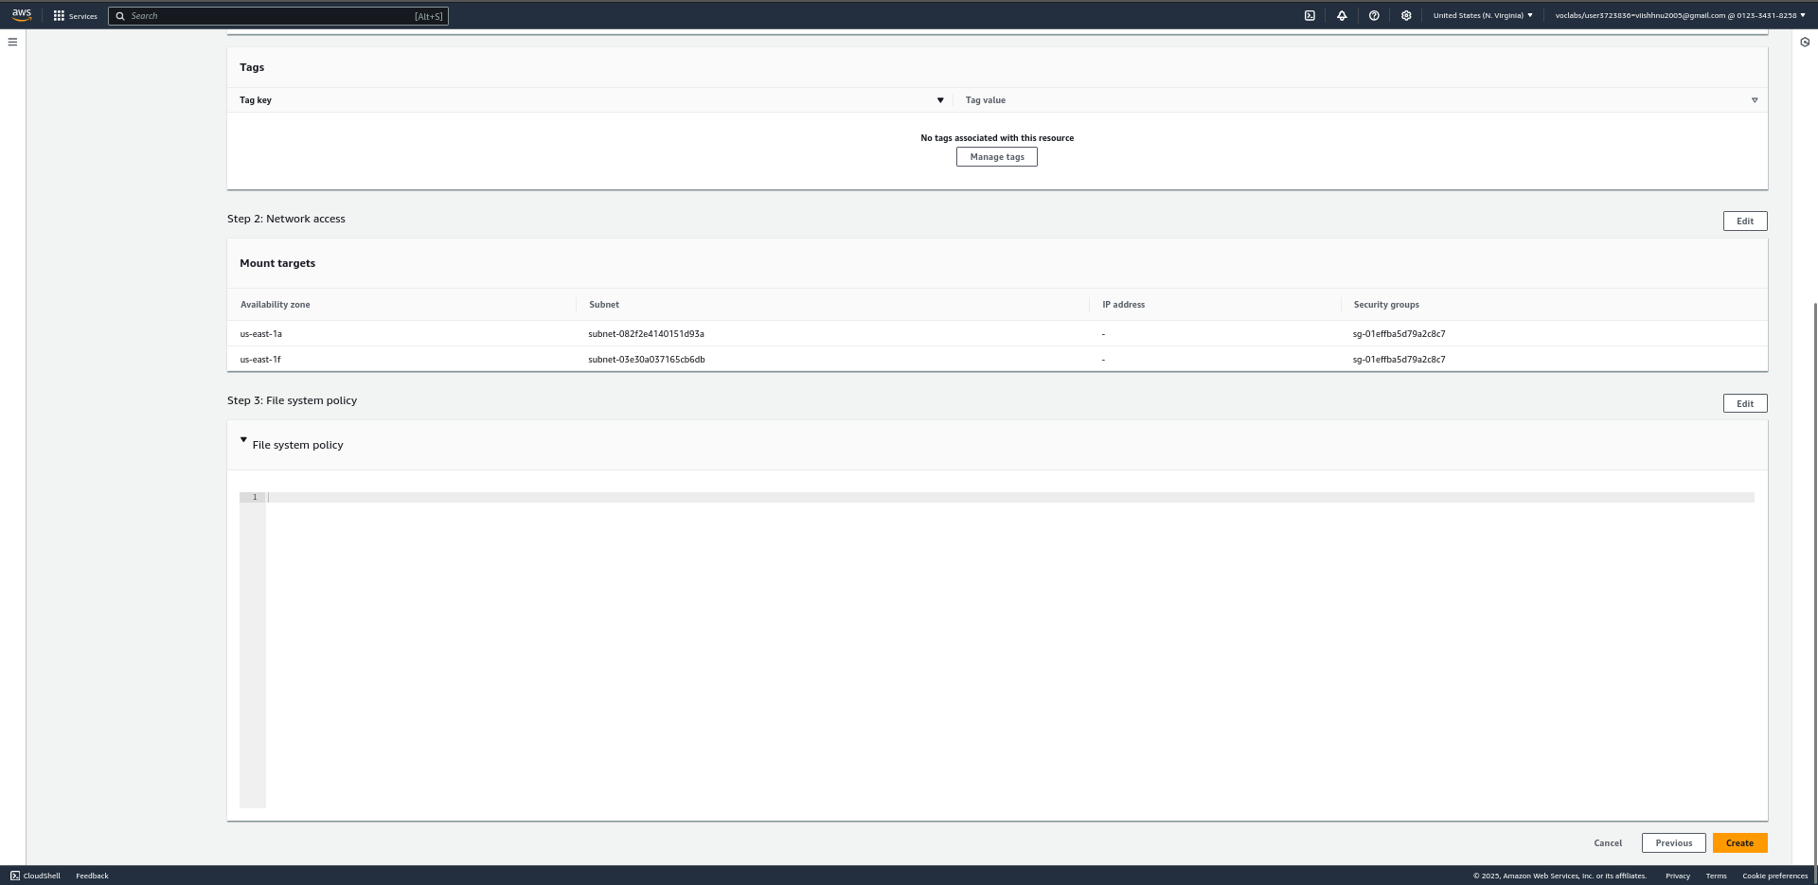

Stepiv) Now connect to ec2-instance from your terminal

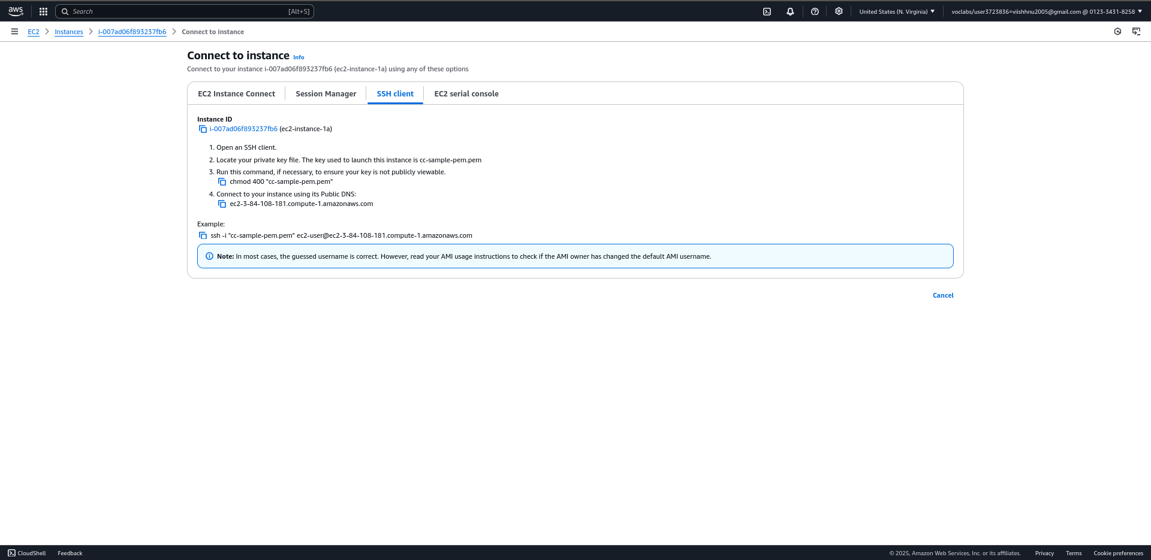

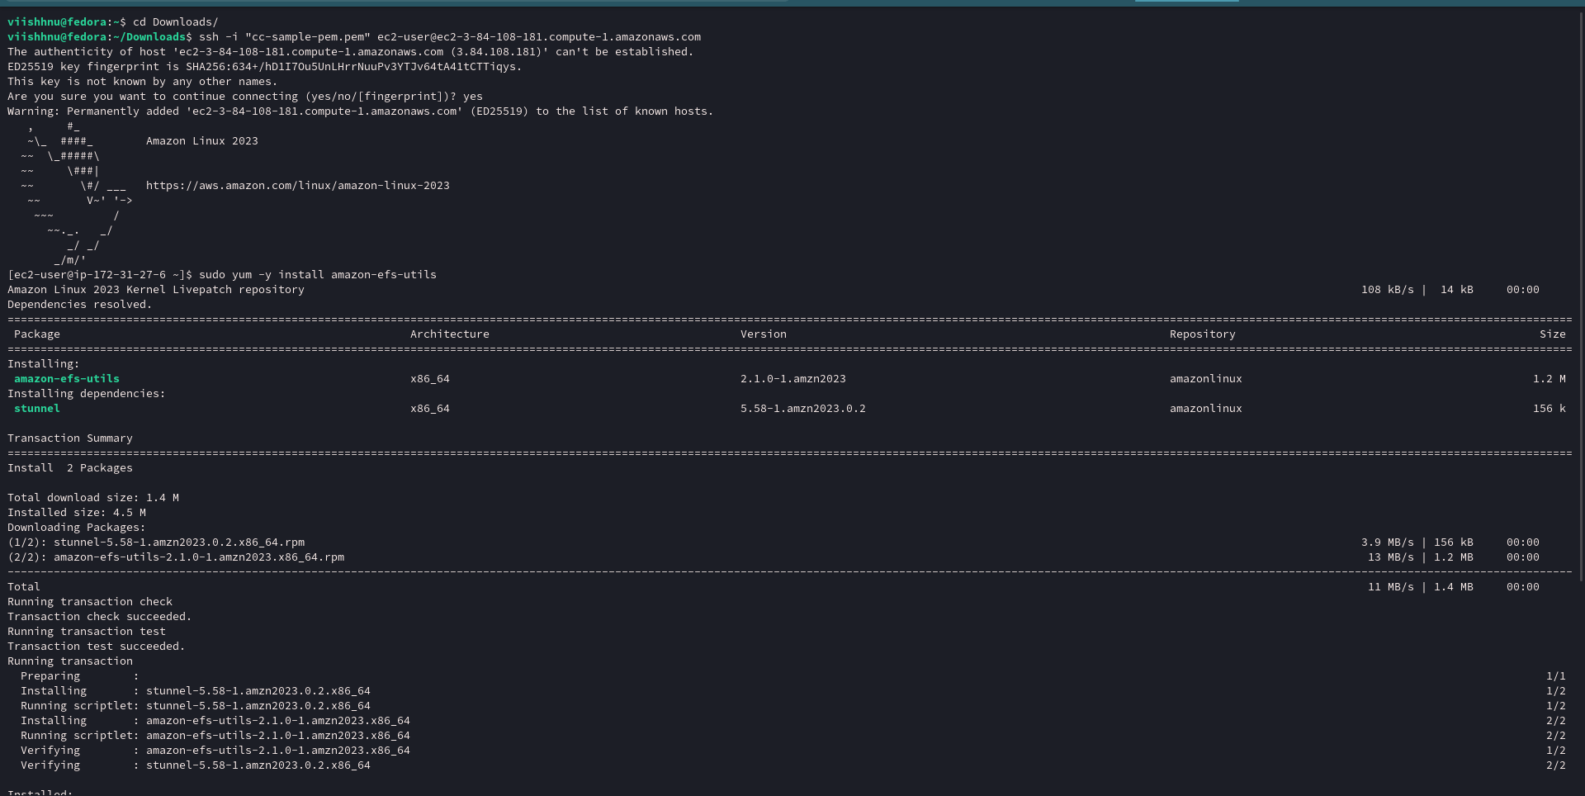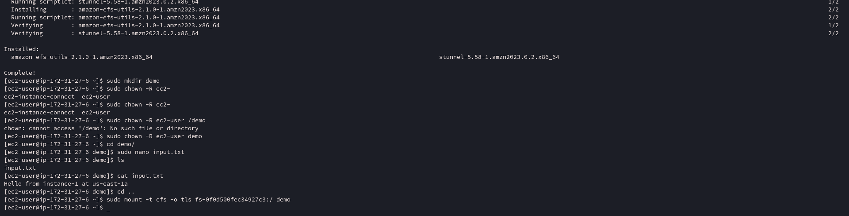

2) Now do the same with another ec2 – instance in us-east-1f

In second termianl connect to another ec2 instance

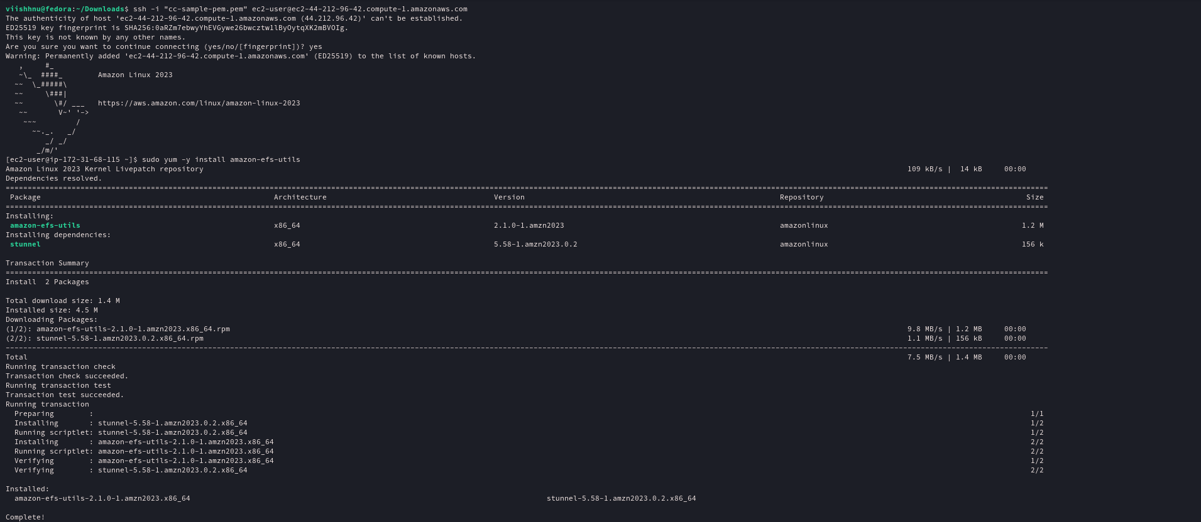





As you can see we accessed the same content from another instance in another availability zone